**SESSION-3**

**INTRODUCTION TO DATABASES**

Questions not done : 9

**1.Create Database**

mysql> create database rdb;

Query OK, 1 row affected (0.03 sec)

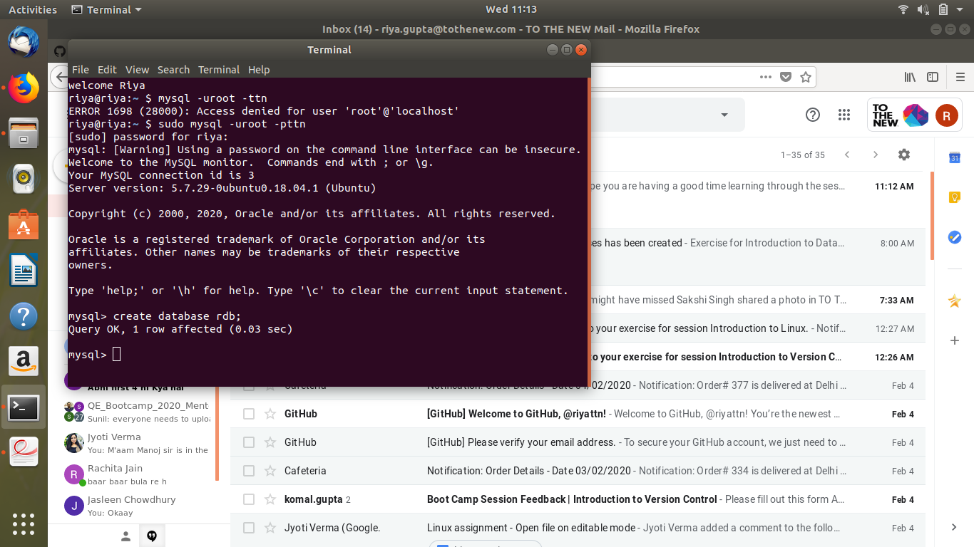

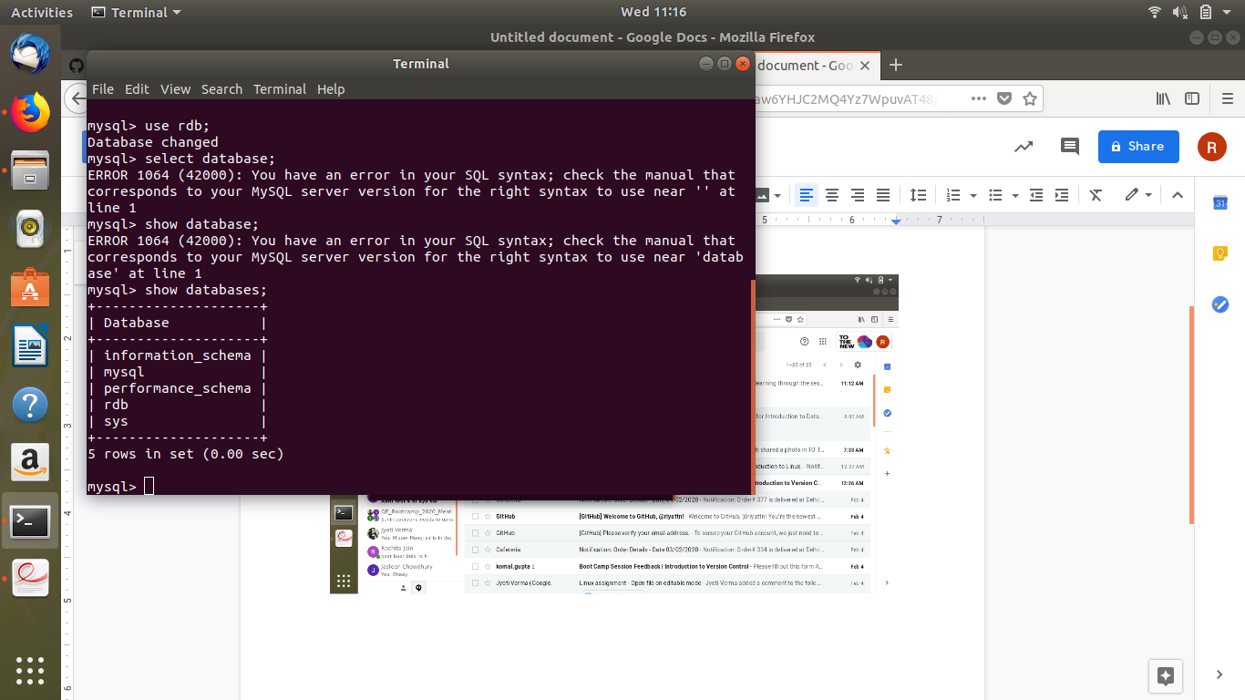

**2. Create schema**

Type desc command, and then put image of all the tables created.

mysql> show tables;

+---------------+

| Tables_in_rdb |

+---------------+

| customer |

| orders |

| product |

| salesman |

+---------------+

4 rows in set (0.00 sec)

mysql> desc customer;

+----------+-------------+------+-----+---------+-------+

| Field | Type | Null | Key | Default | Extra |

+----------+-------------+------+-----+---------+-------+

| cid | int(10) | NO | PRI | NULL | |

| cname | varchar(32) | YES | MUL | NULL | |

| cemail | varchar(32) | YES | | NULL | |

| ccontact | bigint(10) | YES | | NULL | |

| enabled | bit(1) | YES | | b'1' | |

+----------+-------------+------+-----+---------+-------+

5 rows in set (0.00 sec)

mysql> desc orders;

+----------+---------+------+-----+---------+-------+

| Field | Type | Null | Key | Default | Extra |

+----------+---------+------+-----+---------+-------+

| oid | int(11) | NO | PRI | NULL | |

| cust_id | int(11) | YES | MUL | NULL | |

| sales_id | int(11) | YES | MUL | NULL | |

+----------+---------+------+-----+---------+-------+

3 rows in set (0.01 sec)

mysql> desc product;

+-------+-------------+------+-----+---------+----------------+

| Field | Type | Null | Key | Default | Extra |

+-------+-------------+------+-----+---------+----------------+

| pid | int(1) | NO | PRI | NULL | auto_increment |

| pname | varchar(10) | YES | | NULL | |

+-------+-------------+------+-----+---------+----------------+

2 rows in set (0.01 sec)

mysql> desc salesman;

+--------+-------------+------+-----+---------+-------+

| Field | Type | Null | Key | Default | Extra |

+--------+-------------+------+-----+---------+-------+

| sid | int(11) | NO | PRI | NULL | |

| sname | varchar(20) | YES | | NULL | |

| semail | varchar(10) | YES | | NULL | |

+--------+-------------+------+-----+---------+-------+

3 rows in set (0.01 sec)

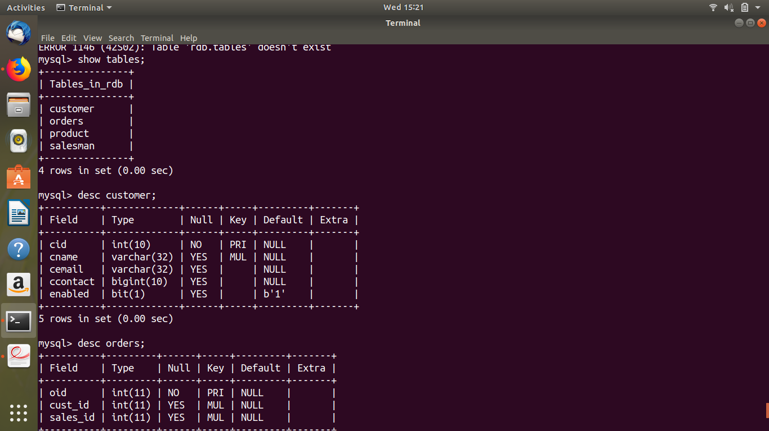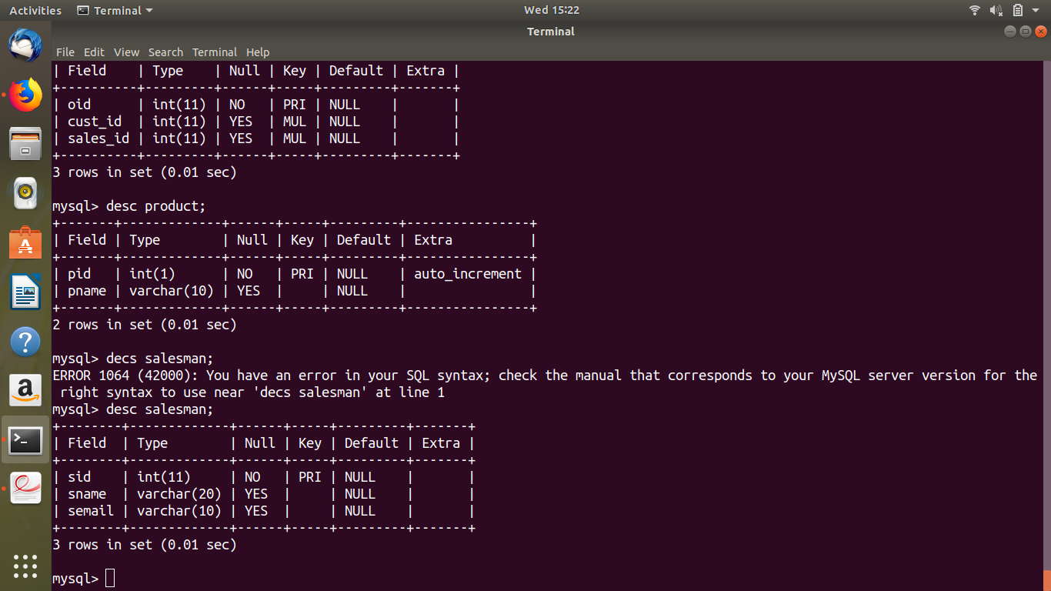

**3.Create table**

mysql> create table customer(cid int(10), cname varchar(32), cemail varchar(32),ccontact int(10));

Query OK, 0 rows affected (0.05 sec)

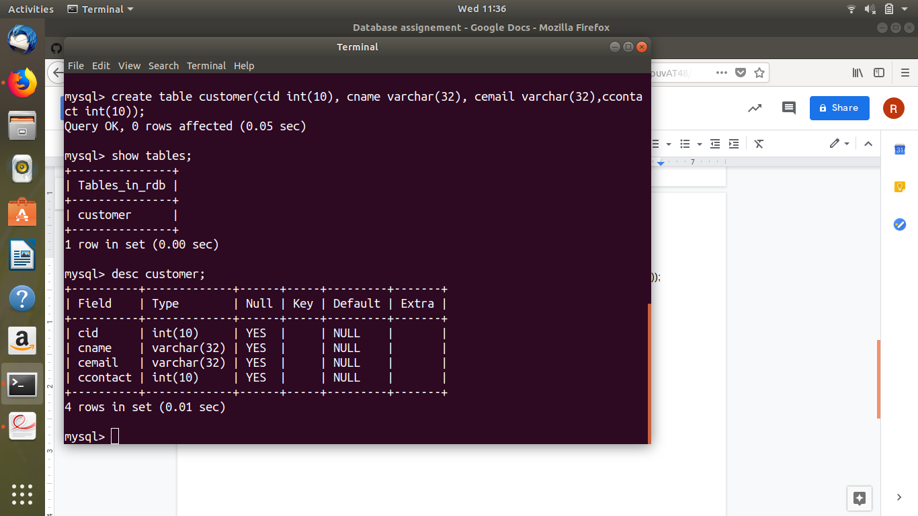

**4.Insert sample data**

mysql> insert into customer values(1,'Riya','riya.gupta@tothenew.com',12345);

Query OK, 1 row affected (0.01 sec)

mysql> insert into customer values(2,'Vaibhav','[vaibhav.sharma@tothenew.com](mailto:vaibhav.sharma@tothenew.com)',1234567890);

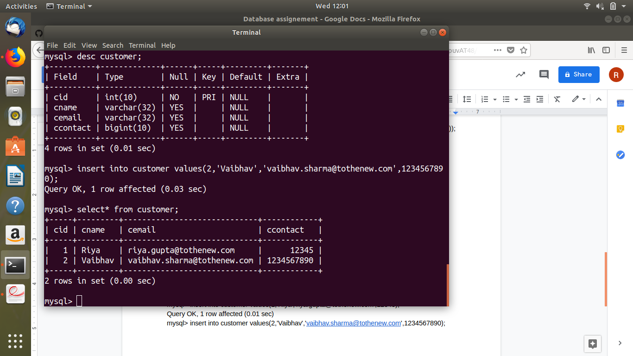

**5.Find the sales person having multiple orders.**

mysql> select * from salesman;

+---------+-----------+------------+

| sale_id | sale_name | sale_email |

+---------+-----------+------------+

| 5001 | john | j@abc.com |

| 5002 | jack | joc@ac.com |

| 5003 | kim | k@ac.com |

+---------+-----------+------------+

3 rows in set (0.00 sec)

mysql> select * from customer;

+-------------+-----------+---------+

| customer_id | cust_name | sale_id |

+-------------+-----------+---------+

| 3002 | Riya | 5001 |

| 3005 | Tanya | 5003 |

| 3007 | Divya | 5002 |

| 3008 | Ritika | 5001 |

| 3009 | Ritik | 5001 |

+-------------+-----------+---------+

5 rows in set (0.00 sec)

mysql> SELECT * FROM salesman WHERE sale_id IN (SELECT DISTINCT sale_id FROM customer a WHERE EXISTS (SELECT * FROM customer b WHERE b.sale_id=a.sale_id AND b.cust_name<>a.cust_name));

+---------+-----------+------------+

| sale_id | sale_name | sale_email |

+---------+-----------+------------+

| 5001 | john | j@abc.com |

+---------+-----------+------------+

1 row in set (0.00 sec)

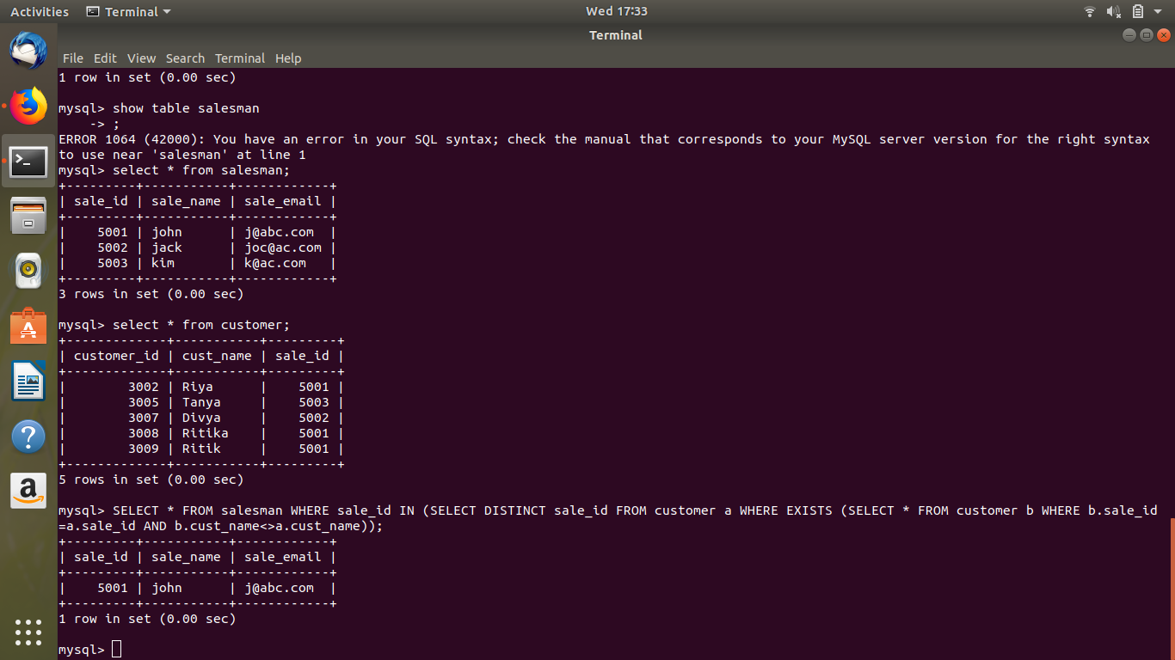

**6.Find the all sales person details along with order details.**

mysql> select * from salesman;

+---------+-----------+------------+

| sale_id | sale_name | sale_email |

+---------+-----------+------------+

| 5001 | john | j@abc.com |

| 5002 | jack | joc@ac.com |

| 5003 | kim | k@ac.com |

+---------+-----------+------------+

3 rows in set (0.00 sec)

mysql> select * from orders;

+-----+-------------+-------------+

| oid | salesman_id | description |

+-----+-------------+-------------+

| 1 | 5001 | Laptop |

| 2 | 5002 | phone |

| 3 | 5003 | phone |

| 4 | 5001 | ipad |

+-----+-------------+-------------+

4 rows in set (0.00 sec)

**mysql> select * from salesman s left join orders o on s.sale_id = o.salesman_id;**

+---------+-----------+------------+------+-------------+-------------+

| sale_id | sale_name | sale_email | oid | salesman_id | description |

+---------+-----------+------------+------+-------------+-------------+

| 5001 | john | j@abc.com | 1 | 5001 | Laptop |

| 5002 | jack | joc@ac.com | 2 | 5002 | phone |

| 5003 | kim | k@ac.com | 3 | 5003 | phone |

| 5001 | john | j@abc.com | 4 | 5001 | ipad |

+---------+-----------+------------+------+-------------+-------------+

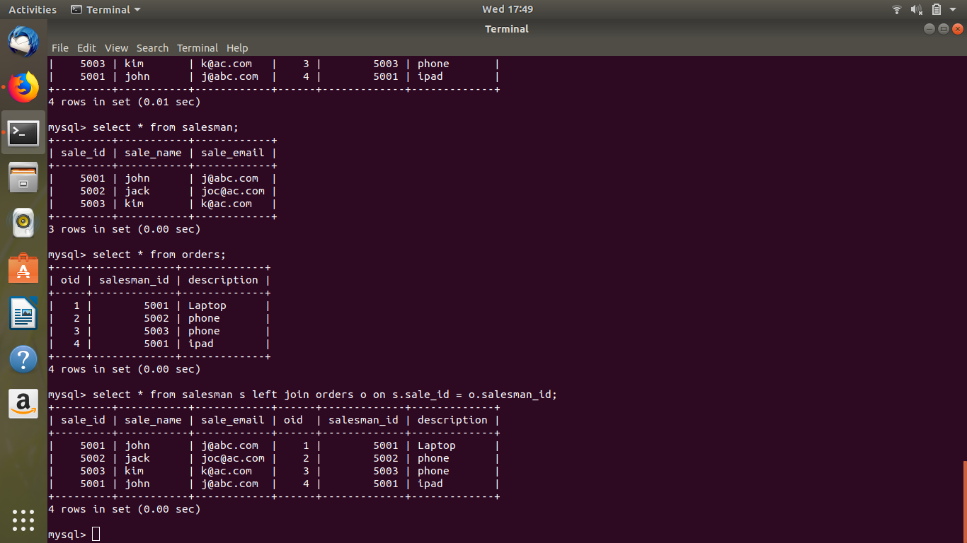

**7.Create index**

mysql> create index cindex1 on customer (cname);

**8.How to show index on a table**

mysql> show index from customer;

+----------+------------+----------+--------------+-------------+-----------+-------------+----------+--------+------+------------+---------+---------------+

| Table | Non_unique | Key_name | Seq_in_index | Column_name | Collation | Cardinality | Sub_part | Packed | Null | Index_type | Comment | Index_comment |

+----------+------------+----------+--------------+-------------+-----------+-------------+----------+--------+------+------------+---------+---------------+

| customer | 0 | PRIMARY | 1 | cid | A | 4 | NULL | NULL | | BTREE | | |

| customer | 1 | cindex | 1 | cid | A | 4 | NULL | NULL | | BTREE | | |

| customer | 1 | cindex1 | 1 | cname | A | 4 | NULL | NULL | YES | BTREE | | |

+----------+------------+----------+--------------+-------------+-----------+-------------+----------+--------+------+------------+---------+---------------+

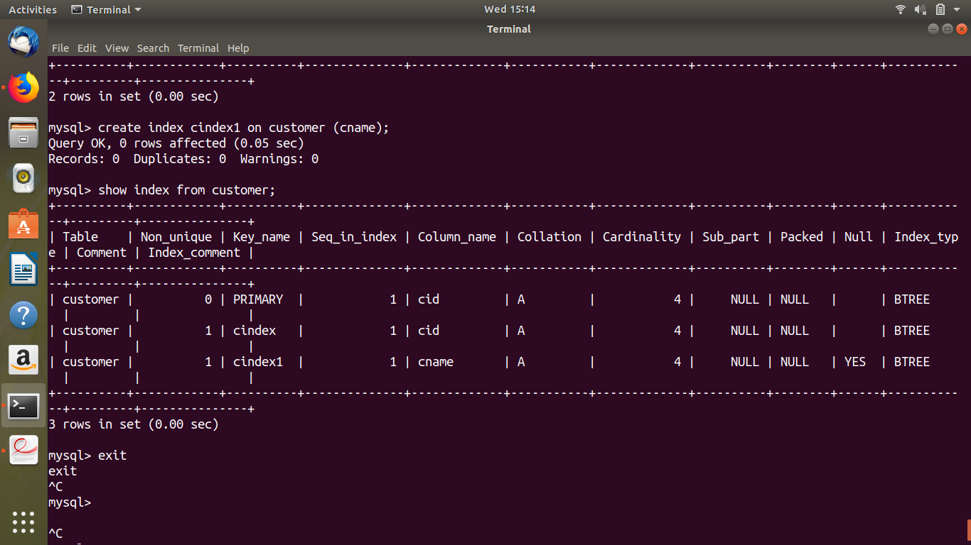

**9.Find the order number, sale person name, along with the customer to whom that order belongs to.**

mysql> select oid, sale_name, cust_name from orders o inner join salesman s on o.salesman_id = s.sale id inner join customer c on c.sale_id = o.salesman_id;

ERROR 1064 (42000): You have an error in your SQL syntax; check the manual that corresponds to your MySQL server version for the right syntax to use near 'id inner join customer c on c.sale_id = o.salesman_id' at line 1

ANSWER:

mysql> select oid, sale_name, cust_name from orders o inner join salesman s on o.salesman_id = s.sale_id inner join customer c on c. sale_id = s.sale_id;

